**Bahria University, Lahore Campus**

Department of Computer Sciences

Lab Journal 03

**(Fall 2023)**

|  |  |  |
| --- | --- | --- |
| Course: | **Digital Communication Network Lab** | Date: 05-10-2023 |
| Course Code: | CSL-320 | Max Marks: 20 |
| Faculty’s Name: | Dawood Akram | Lab Engineer: Muhammad Umar Nasir |

Name: _Affan ahmad __ Enroll No: _03-134221-______

**Objective(s):**

To develop an understanding of the basic functions of Packet Tracer. Create/model a simple Ethernet network using two hosts and a hub. Observe traffic behavior on the network. Observe data flow of ARP broadcasts and pings.

## Tool(s) used:

CISCO Packet Tracer

## Task 01Create a logical network diagram with two PCs and a hub

The bottom left-hand corner of the Packet Tracer screen displays eight icons that represent device categories or groups, such as Routers, Switches, or End Devices.

Moving the cursor over the device categories will show the name of the category in the box. To select a device, first select the device category. Once the device category is selected, the options within that category appear in the box next to the category listings. Select the device option that is required.

1. Select **End Devices** from the options in the bottom left-hand corner. Drag and drop two generic PCs onto your design area.

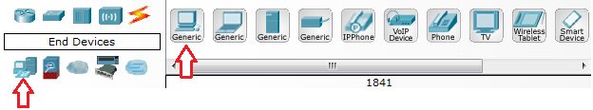

1. Select **Hubs** from the options in the bottom left-hand corner. Add a hub to the prototype network by dragging and dropping a generic hub onto the design area.

1. Select **Connections** from the bottom left-hand corner. Choose a **Copper Straight-through** cable type. Click the first host, **PC0**, and assign the cable to the **FastEthernet** connector. Click the hub, **Hub0**, and select a connection port, **Port 0**, to connect to **PC0**.

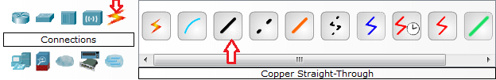

1. Repeat Step c for the second PC, **PC1**, to connect the PC to **Port 1** on the hub.

**NETWORK DIAGRAM**

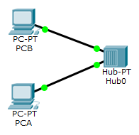

There should be green dots at both ends of each cable connection. If not, check the cable type selected.

## Task 02 Configure host names and IP addresses on the PCs

1. Click PC0. A PC0 window will appear.
2. From the PC0 window, select the **Config** tab. Change the PC **Display Name** to **PC-A**. (An error message window will appear warning that changing the device name may affect scoring of the activity. Ignore this error message.)

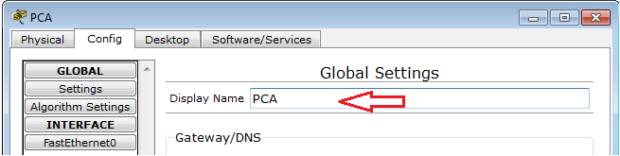

1. Select the **FastEthernet** tab on the left and add the IP address of **192.168.1.1** and subnet mask of **255.255.255.0**. Close the PC-A configuration window by selecting the **x** in the upper right hand corner.

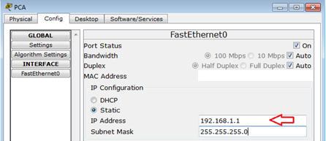

1. Click PC1. Select the **Config** tab. Change the PC **Display Name** to **PC-B**. Select the **FastEthernet** tab on the left and add the IP address of **192.168.1.2** and subnet mask of **255.255.255.0**. Close the PC-B configuration window.

## Task 03 Observe the flow of data from PC-A to PC-B by creating network traffic

1. Switch to **Simulation** mode by selecting the tab that is partially hidden behind the **Realtime** tab in the bottom right-hand corner. The tab has the icon of a stopwatch on it.

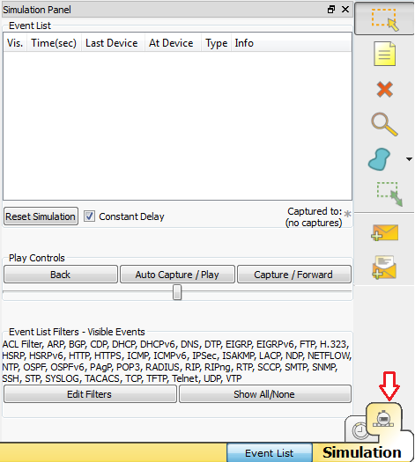

1. Click the **Edit Filters** button in the **Edit List Filters** area. Clicking the **Edit Filters** button will create a pop-up window. In the pop-up window, click the **Show All/None** box to deselect every filter. Select just the **ARP** and **ICMP** filters.

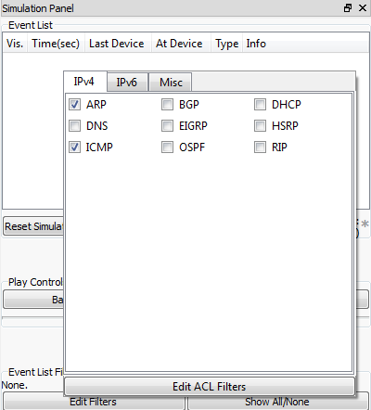

1. Select a **Simple PDU** by clicking the closed envelope on the right vertical toolbar. Move your cursor to the display area of your screen. Click **PC-A** to establish the source. Move your cursor to **PC-B** and click to establish the destination.

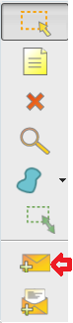

1. Notice that two envelopes are now positioned beside PC-A. One envelope is ICMP, while the other is ARP. The Event List in the Simulation Panel will identify exactly which envelope represents ICMP and which represents ARP.
2. Select **Auto Capture / Play** from the **Play Controls** area of the Simulation Panel. Below the **Auto Capture / Play** button is a horizontal bar, with a vertical button that controls the speed of the simulation.

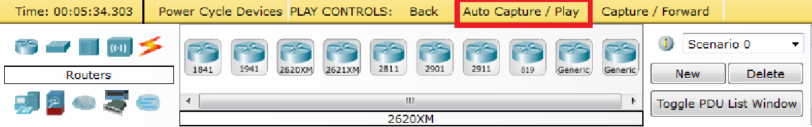

1. Dragging the button to the right will speed up the simulation, while dragging is to the left will slow down the simulation. The animation will run until the message window *No More Events* appears. All requested events have been completed. Select OK to close the message box.

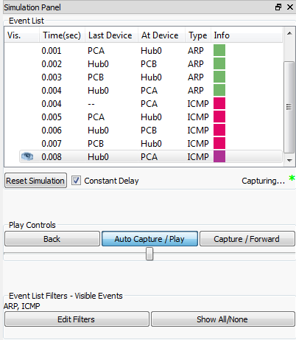

1. Choose the **Reset Simulation** button in the Simulation Panel. Notice that the ARP envelope is no longer present. This has reset the simulation but has not cleared any configuration changes or dynamic table entries, such as ARP table entries. The ARP request is not necessary to complete the **ping** command because PC-A already has the MAC address in the ARP table.

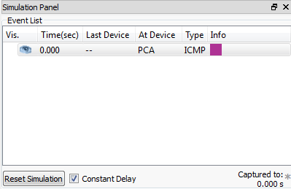

1. Choose the **Capture / Forward** button. The ICMP envelope will move from the source to the hub and stop. The **Capture / Forward** button allow you to run the simulation one step at a time. Continue selecting the **Capture / Forward** button until you complete the event.
2. Choose the **Power Cycle Devices** button on the bottom left, above the device icons.

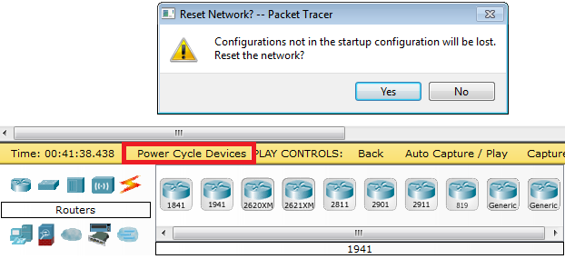

1. An error message will appear asking you to confirm reset. Choose **Yes**. Now both the ICMP and ARP envelops are present again. The **Reset Network** button will clear any configuration changes not saved and will clear all dynamic table entries, such as the ARP and MAC table entries.

## Task 04 View ARP Tables on each PC

1. Choose the **Auto Capture / Play** button to repopulate the ARP table on the PCs. Click **OK** when the no more Events message appears.
2. Select the magnifying glass on the right vertical tool bar.
3. Click **PC-A**. The ARP table for PC-A will appear. Notice that PC-A does have an ARP entry for **PC-B**.
4. View the ARP tables for **PC-B** as well. Close all ARP tables.